**Applying color to UI**

Color is applied to UI elements and components in consistent and meaningful ways.



Introducing design tokens

Streamline your workflow and improve consistency across your product with design tokens, part of Material Design 3. These small, reusable design decisions replace static values with self-explanatory names.

* open\_in\_new[Design tokens in Material Design 3](https://m3.material.io/foundations/design-tokens/overview)

CONTENTS

* [Usage](https://m2.material.io/design/color/applying-color-to-ui.html#usage)
* [Top and bottom app bars](https://m2.material.io/design/color/applying-color-to-ui.html#top-and-bottom-app-bars)
* [Backdrop](https://m2.material.io/design/color/applying-color-to-ui.html#backdrop)
* [Sheets and surfaces](https://m2.material.io/design/color/applying-color-to-ui.html#sheets-and-surfaces)
* [Buttons, chips and selection controls](https://m2.material.io/design/color/applying-color-to-ui.html#buttons-chips-and-selection-controls)
* [**Typography and iconography**](https://m2.material.io/design/color/applying-color-to-ui.html#typography-and-iconography)

**Usage**link

These guidelines describe a variety of UI components and elements where color application is important.

**Principles**

Color should be applied throughout a UI consistently and be compatible with the brand it represents. Color should create distinction between elements, with sufficient contrast...

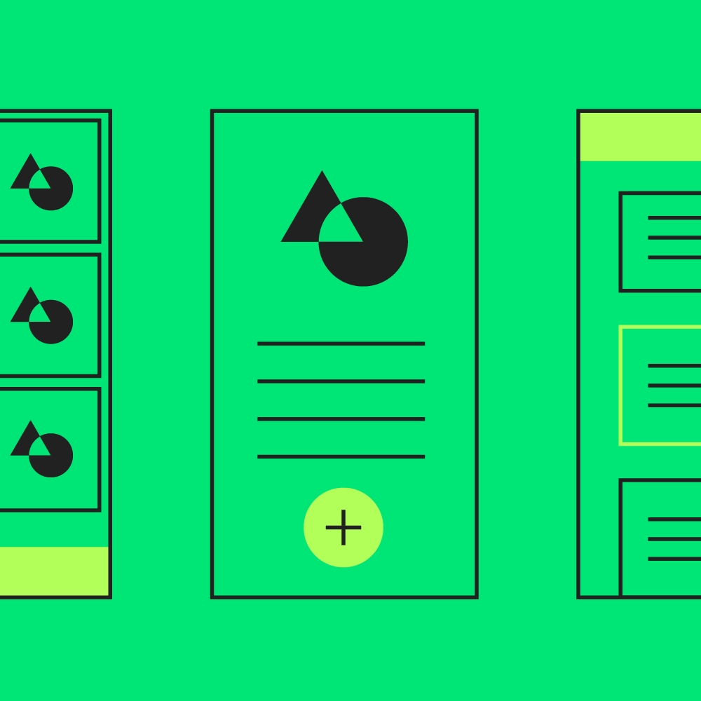

**Consistent**

Color should be applied throughout a UI consistently and be compatible with the brand it represents.

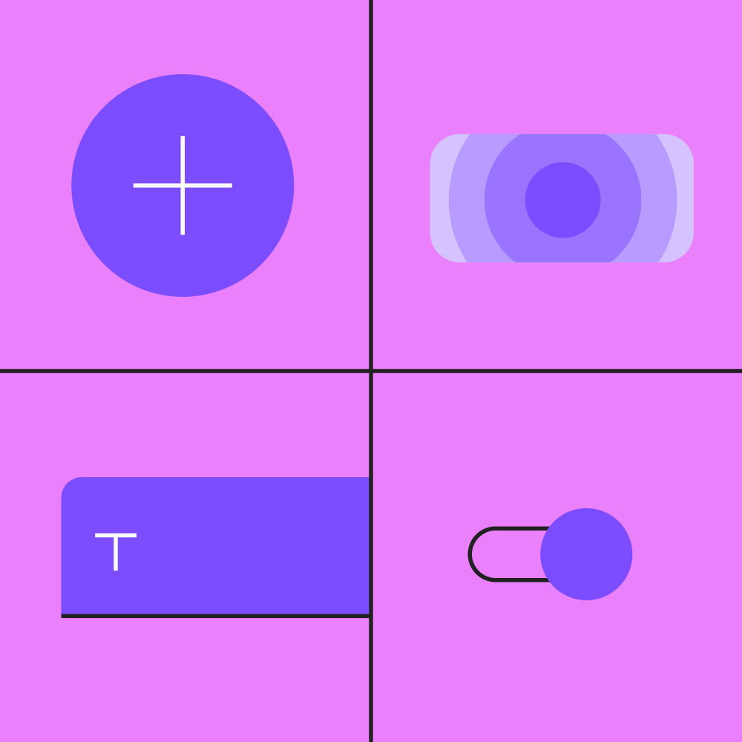

**Distinct**

Color should create distinction between elements, with sufficient contrast between them.

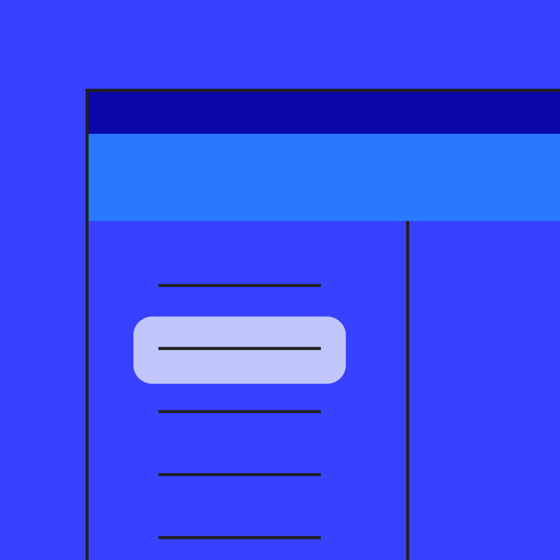

**Intentional**

Color should be applied purposefully as it can convey meaning in multiple ways, such as relationships between elements and degrees of hierarchy.

**Top and bottom app bars**link

The way color is applied to top and bottom app bars helps users identify them and understand their relationship to surrounding elements.

[Top app bar](https://m2.material.io/components/app-bars-top" \o "Top app bar" \t "_self)

[The top app bar displays information and actions relating to the current view.](https://m2.material.io/components/app-bars-top" \o "Top app bar" \t "_self)

[Related articlearrow\_downward](https://m2.material.io/components/app-bars-top" \o "Top app bar" \t "_self)

[Bottom app bars](https://m2.material.io/components/app-bars-bottom" \o "Bottom app bars" \t "_self)

[Provide reachable access to a bottom navigation drawer and actions on mobile devices.](https://m2.material.io/components/app-bars-bottom" \o "Bottom app bars" \t "_self)

[Related articlearrow\_downward](https://m2.material.io/components/app-bars-bottom" \o "Bottom app bars" \t "_self)

[Reply](https://m2.material.io/design/material-studies/reply.html" \o "Reply" \t "_self)

[Reply is an email app that uses Material Design components and Material Theming to create an on-brand communication experience.](https://m2.material.io/design/material-studies/reply.html" \o "Reply" \t "_self)

[Related articlearrow\_downward](https://m2.material.io/design/material-studies/reply.html" \o "Reply" \t "_self)

**Identifying app bars**

Top and bottom app bars use an app’s primary color. System bars can use a dark or light variant of the primary color to separate...

Top and bottom app bars use an app’s primary color. System bars can use a dark or light variant of the primary color to separate system content from top app bar content.

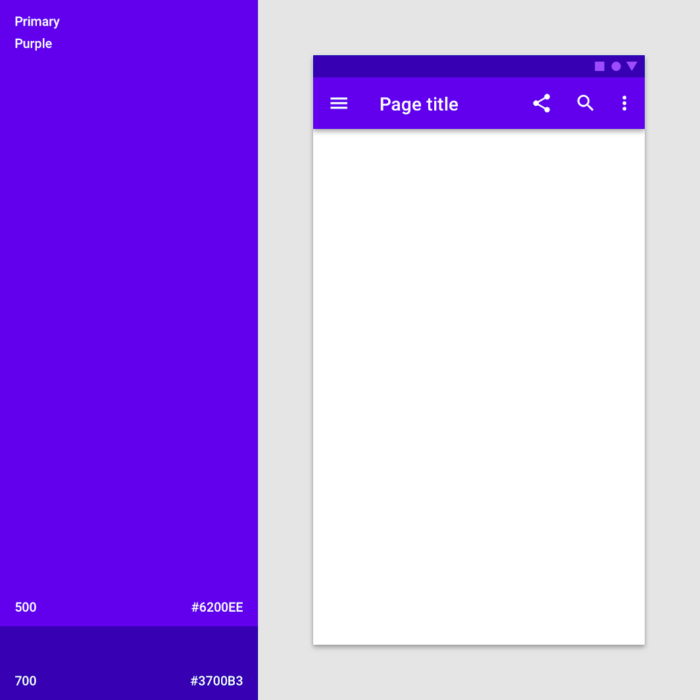

DoThe primary color (purple 500) is used on this top app bar, and a dark primary variant (purple 700) is used on the system bar.

To emphasize the difference between app bars and other surfaces, use a secondary color on nearby components such as the floating action button (FAB).

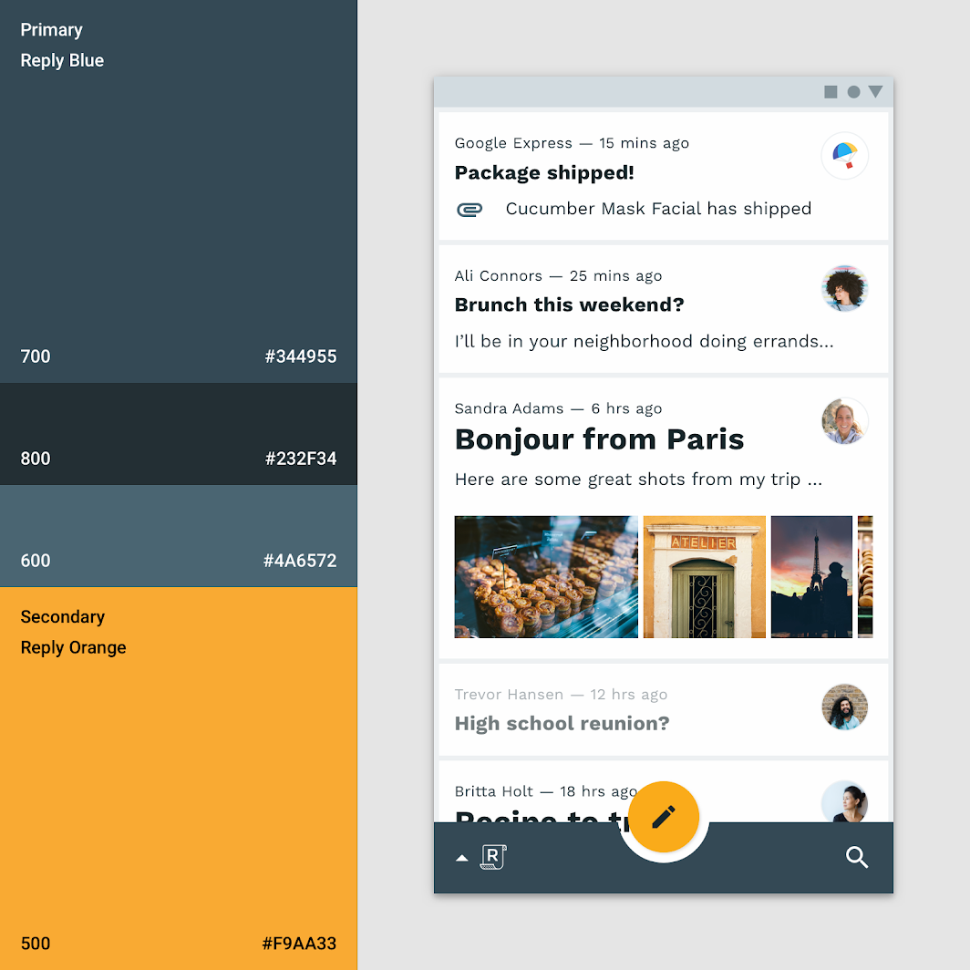

DoThe primary color (blue 700) is used on this bottom app bar, and the secondary color (orange 500) is used on the floating action button.

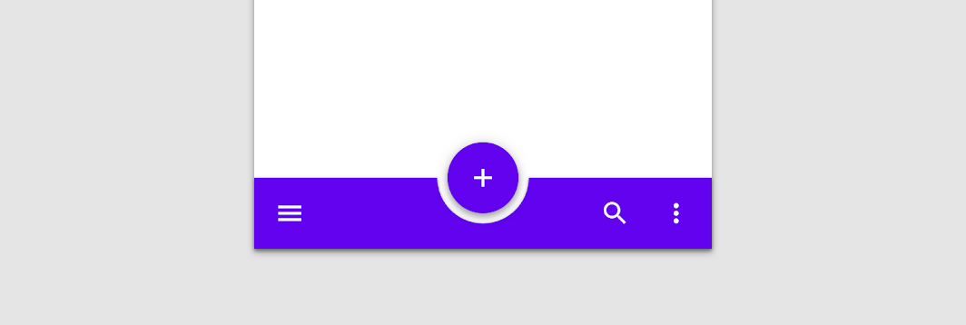

CautionIf the bottom app bar and floating action button are the same color, use shadow or alternate means to create enough distinction between them.

**Blending an app bar with the background**

When an app’s top or bottom app bar color is the same color as the background color, they blend together, placing emphasis on an app’s...

When an app’s top or bottom app bar color is the same color as the background color, they blend together, placing emphasis on an app’s content instead of its structure.

volume\_off

Both this app’s top app bar color and background color is the primary color: white. However, on scroll the top app bar gains a shadow, showing it has an elevation higher than the content that scrolls behind it.

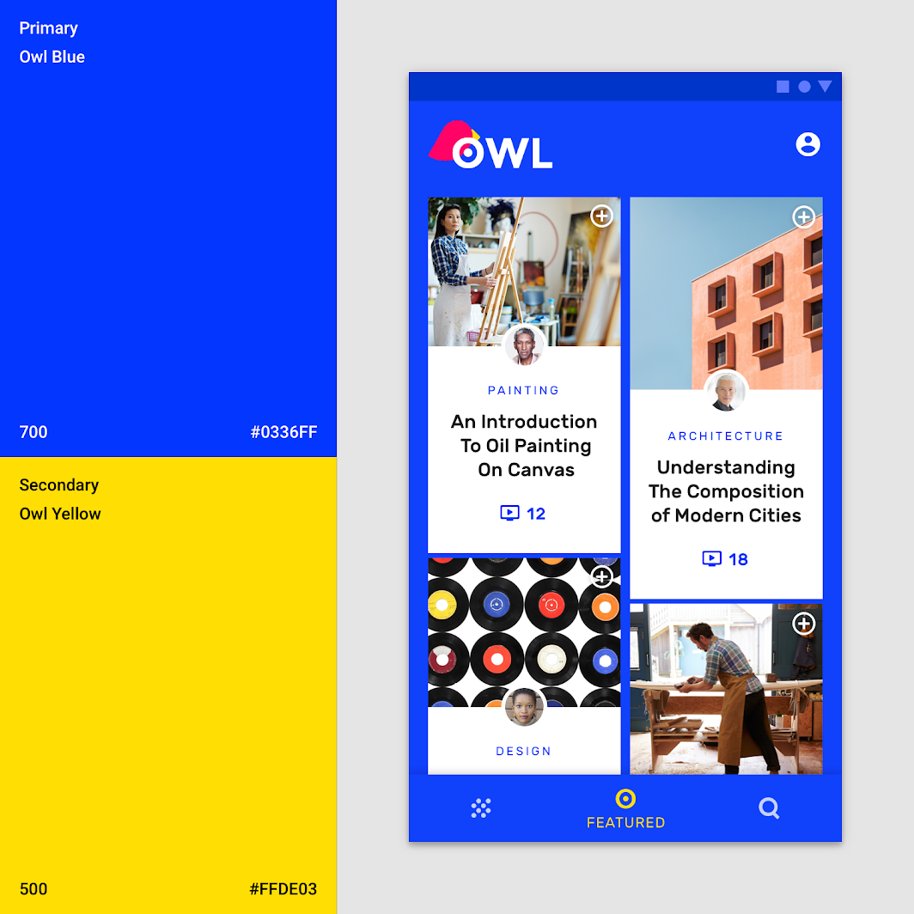

This app’s bright, seamless layout uses its primary blue (blue 700) color for app bars, bottom navigation, and the background color, so individual elements stand out less, and content stands out more. The activation state uses the secondary yellow. It includes a shadow on the bottom navigation to show the elevation division between surfaces.

[Fortnightly](https://m2.material.io/design/material-studies/fortnightly.html" \o "Fortnightly" \t "_self)

[A news app that uses Material Design components and Material Theming to create an on-brand, content-focused experience.](https://m2.material.io/design/material-studies/fortnightly.html" \o "Fortnightly" \t "_self)

[Related articlearrow\_downward](https://m2.material.io/design/material-studies/fortnightly.html" \o "Fortnightly" \t "_self)

[Owl](https://m2.material.io/design/material-studies/owl.html" \o "Owl" \t "_self)

[Owl is an educational app that provides courses for people who want to explore and learn new skills.](https://m2.material.io/design/material-studies/owl.html" \o "Owl" \t "_self)

[Related articlearrow\_downward](https://m2.material.io/design/material-studies/owl.html" \o "Owl" \t "_self)

**Backdrop**link

The backdrop has a front and back layer. To distinguish between these two layers, the baseline back layer color is your primary color and the baseline front layer is white.

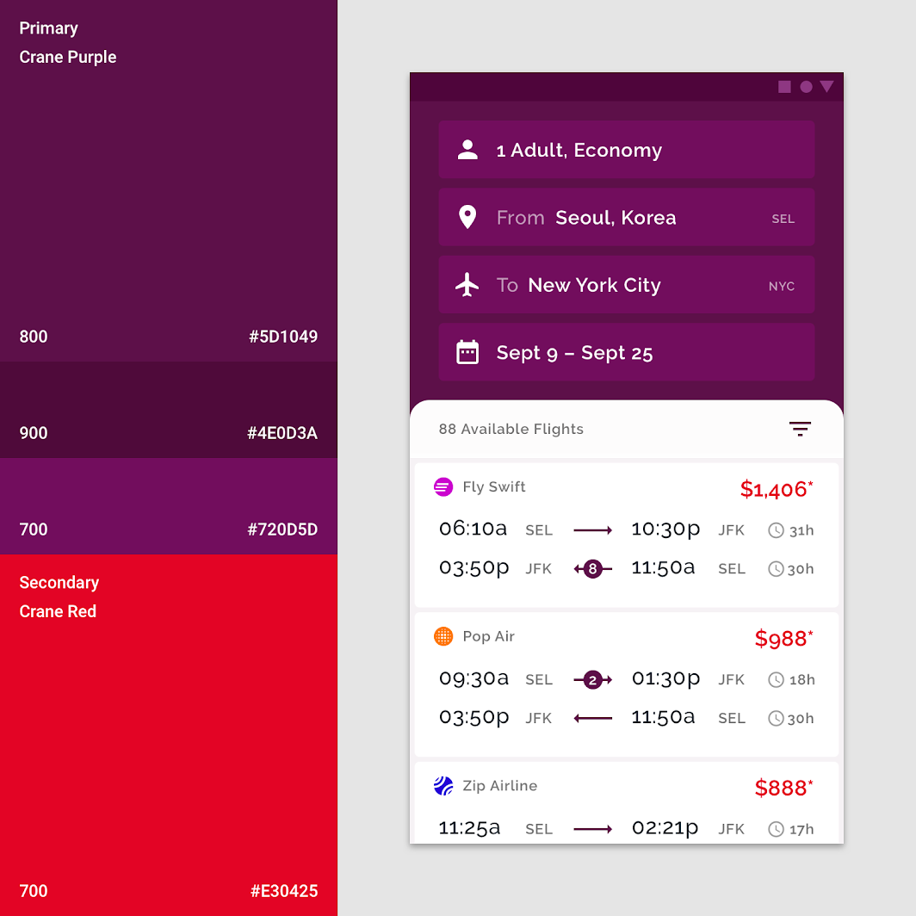

This app uses its primary color (purple 800) on the backdrop’s back layer. The text fields are a light primary variant (purple 700). A secondary color (red 700) is applied as an accent to the flight fares.

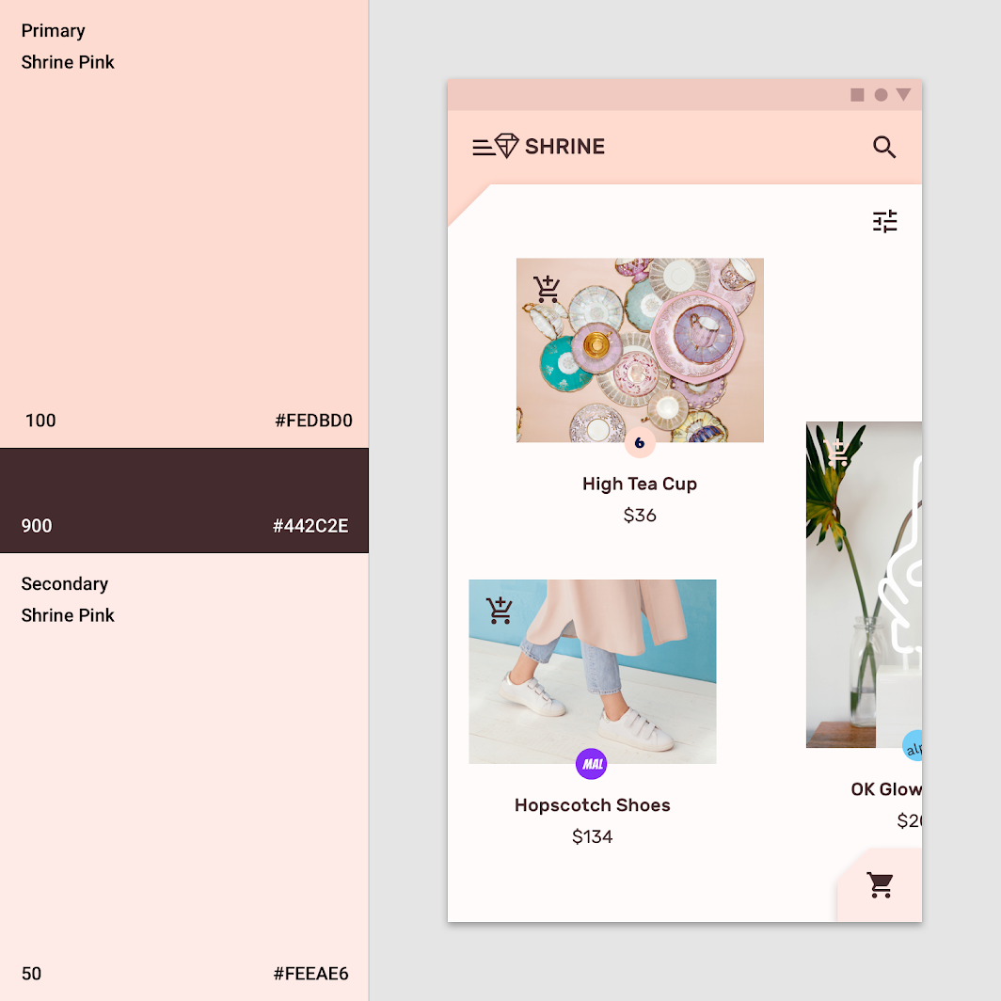

This app uses the primary color (pink 100) for the backdrop’s back layer and the primary dark primary variant (pink 900) for typography and iconography. Additionally, the secondary color (pink 50) is used for the expanding sheet on the front layer.

[Backdrop](https://m2.material.io/components/backdrop" \o "Backdrop" \t "_self)

[Displaying contextual & actionable content behind other surfaces](https://m2.material.io/components/backdrop" \o "Backdrop" \t "_self)

[Related articlearrow\_downward](https://m2.material.io/components/backdrop" \o "Backdrop" \t "_self)

[Crane](https://m2.material.io/design/material-studies/crane.html" \o "Crane" \t "_self)

[A travel app that uses Material Design components and Material Theming to create a personalized on-brand experience.](https://m2.material.io/design/material-studies/crane.html" \o "Crane" \t "_self)

[Related linkarrow\_downward](https://m2.material.io/design/material-studies/crane.html" \o "Crane" \t "_self)

[Shrine](https://m2.material.io/design/material-studies/shrine.html" \o "Shrine" \t "_self)

[Shrine is a lifestyle and fashion brand that demonstrates how Material Design can be used in e-commerce.](https://m2.material.io/design/material-studies/shrine.html" \o "Shrine" \t "_self)

[Related articlearrow\_downward](https://m2.material.io/design/material-studies/shrine.html" \o "Shrine" \t "_self)

**Sheets and surfaces**link

The baseline color for sheets and surfaces, such as bottom sheets, navigation drawers, menus, dialogs, and cards is white. These components can incorporate color to create contrast between other surfaces. Contrast can make surface edges apparent, indicating elevation differences when surfaces overlap.

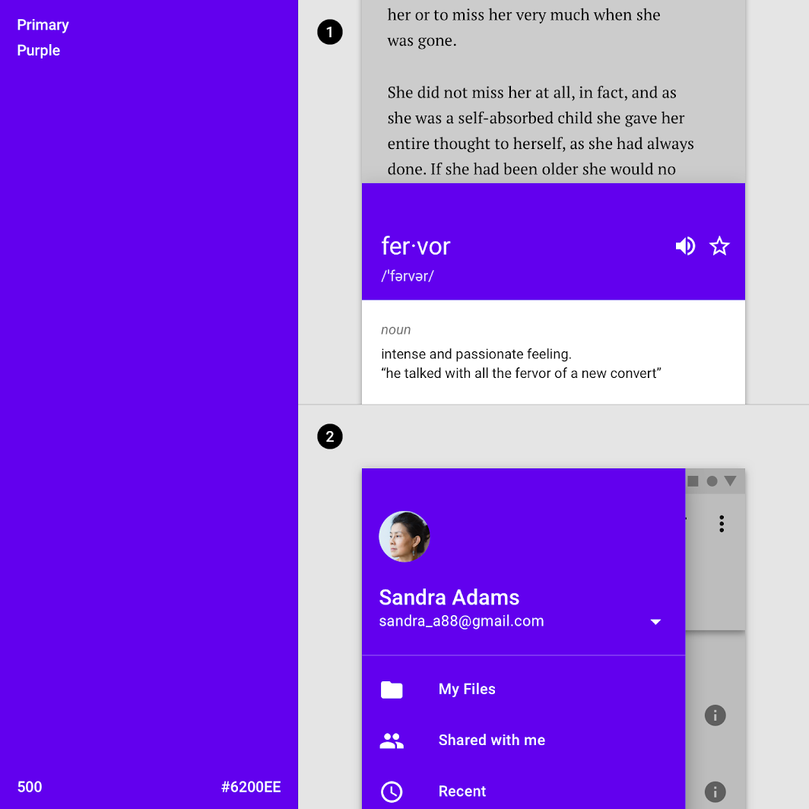

This product has changed the default white to a primary color in a bottom sheet and the navigation drawer.  
1. This product uses a primary color (purple 500) in part of the bottom sheet instead of the baseline white.  
2. This product’s navigation drawer uses its primary color (purple 500) instead of the baseline white.

[Bottom sheets](https://m2.material.io/components/sheets-bottom" \o "Bottom sheets" \t "_self)

[Surfaces containing supplementary content that are anchored to the bottom of the screen.](https://m2.material.io/components/sheets-bottom" \o "Bottom sheets" \t "_self)

[Related articlearrow\_downward](https://m2.material.io/components/sheets-bottom" \o "Bottom sheets" \t "_self)

[Side sheets](https://m2.material.io/components/sheets-side" \l "sheets-side" \o "Side sheets" \t "_self)

[Surfaces containing supplementary content that are anchored to the left or right edge of the screen.](https://m2.material.io/components/sheets-side" \l "sheets-side" \o "Side sheets" \t "_self)

[Related articlearrow\_downward](https://m2.material.io/components/sheets-side" \l "sheets-side" \o "Side sheets" \t "_self)

[Menus](https://m2.material.io/components/menus" \o "Menus" \t "_self)

[Menus display a list of choices on temporary surfaces.](https://m2.material.io/components/menus" \o "Menus" \t "_self)

[Related articlearrow\_downward](https://m2.material.io/components/menus" \o "Menus" \t "_self)

**Modal sheets**

Use contrasting colors on surfaces that appear on-screen temporarily, such as navigation drawers and bottom sheets. Usually these surfaces are white, but you can use...

Use contrasting colors on surfaces that appear on-screen temporarily, such as navigation drawers and bottom sheets. Usually these surfaces are white, but you can use your app’s primary or secondary color.

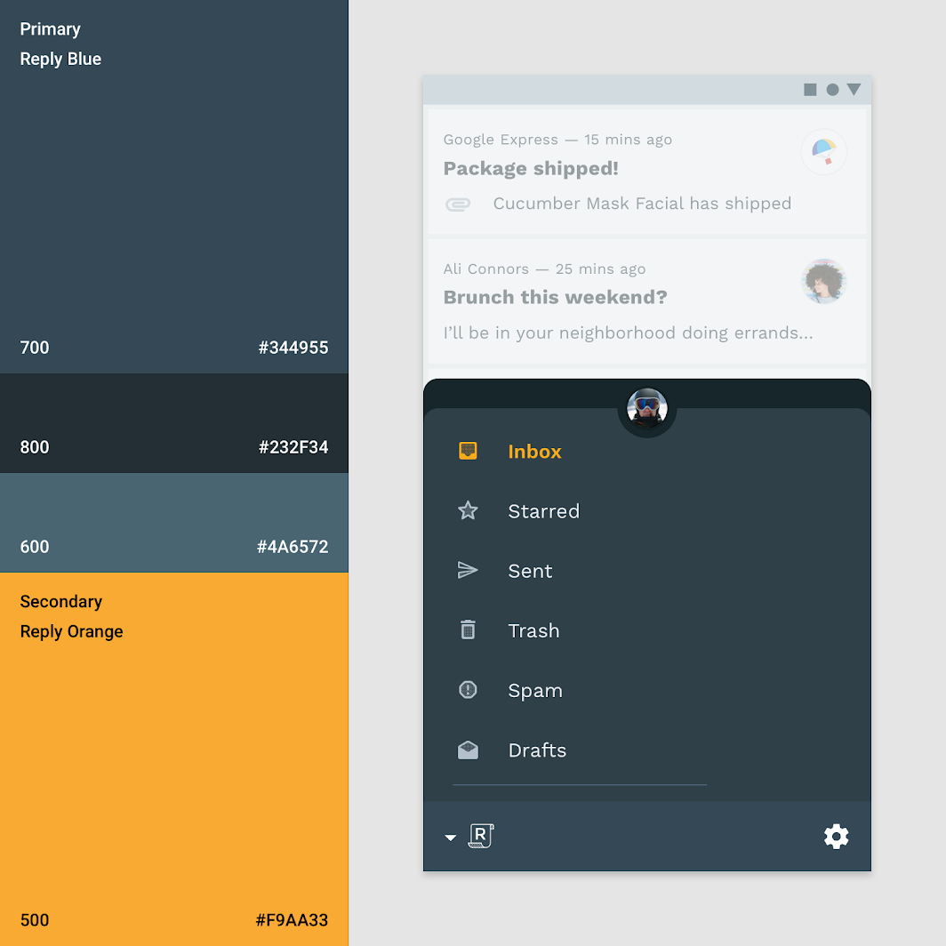

This app uses its primary color blue (blue 700) on the bottom navigation drawer, a primary dark variant (blue 800) for the account switcher, and a secondary color (orange 500) for selection.

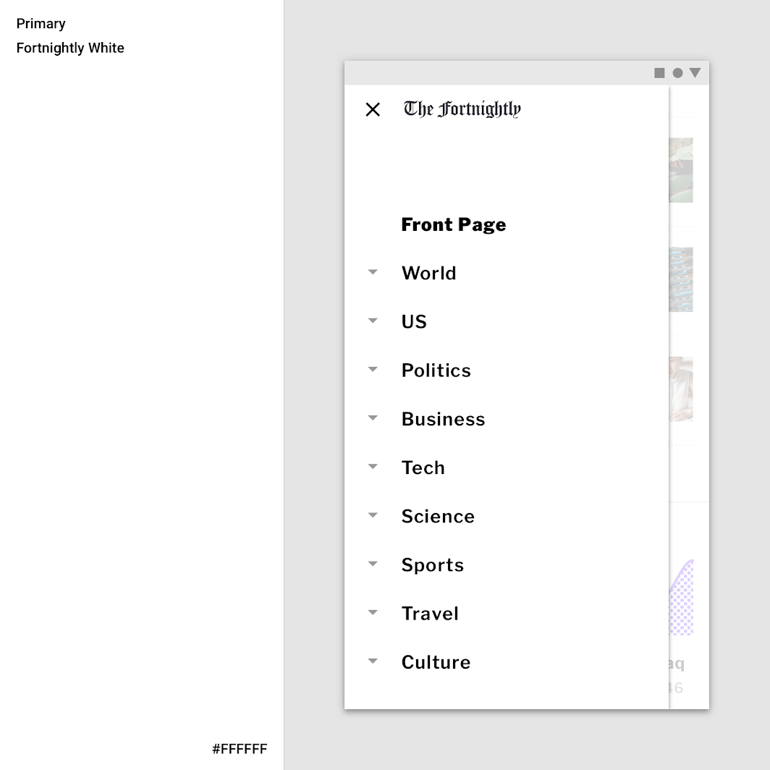

This app uses its primary color (white) for its modal navigation drawer, creating the maximum contrast between the dark typography and the navigation. A white scrim is used to make content behind it less noticeable, as the navigation drawer is the same color as the background.

volume\_off

This app displays a sheet in the bottom right colored with its primary color (pink 500). Upon tap, the sheet expands.

[Reply](https://m2.material.io/design/material-studies/reply.html" \o "Reply" \t "_self)

[Reply is an email app that uses Material Design components and Material Theming to create an on-brand communication experience.](https://m2.material.io/design/material-studies/reply.html" \o "Reply" \t "_self)

[Related articlearrow\_downward](https://m2.material.io/design/material-studies/reply.html" \o "Reply" \t "_self)

[Navigation drawer](https://m2.material.io/components/navigation-drawer" \o "Navigation drawer" \t "_self)

[Navigation drawers provide access to the navigation destinations of your app.](https://m2.material.io/components/navigation-drawer" \o "Navigation drawer" \t "_self)

[Related articlearrow\_downward](https://m2.material.io/components/navigation-drawer" \o "Navigation drawer" \t "_self)

[Fortnightly](https://m2.material.io/design/material-studies/fortnightly.html" \o "Fortnightly" \t "_self)

[A news app that uses Material Design components and Material Theming to create an on-brand, content-focused experience.](https://m2.material.io/design/material-studies/fortnightly.html" \o "Fortnightly" \t "_self)

[Related articlearrow\_downward](https://m2.material.io/design/material-studies/fortnightly.html" \o "Fortnightly" \t "_self)

**Cards**

Cards contain content and links about a single subject. Related Article arrow\_downward The baseline color for cards is white. This color can be customized to...

The baseline color for cards is white. This color can be customized to express brand or improve legibility. Card text and icons can also use the color theme to improve legibility.

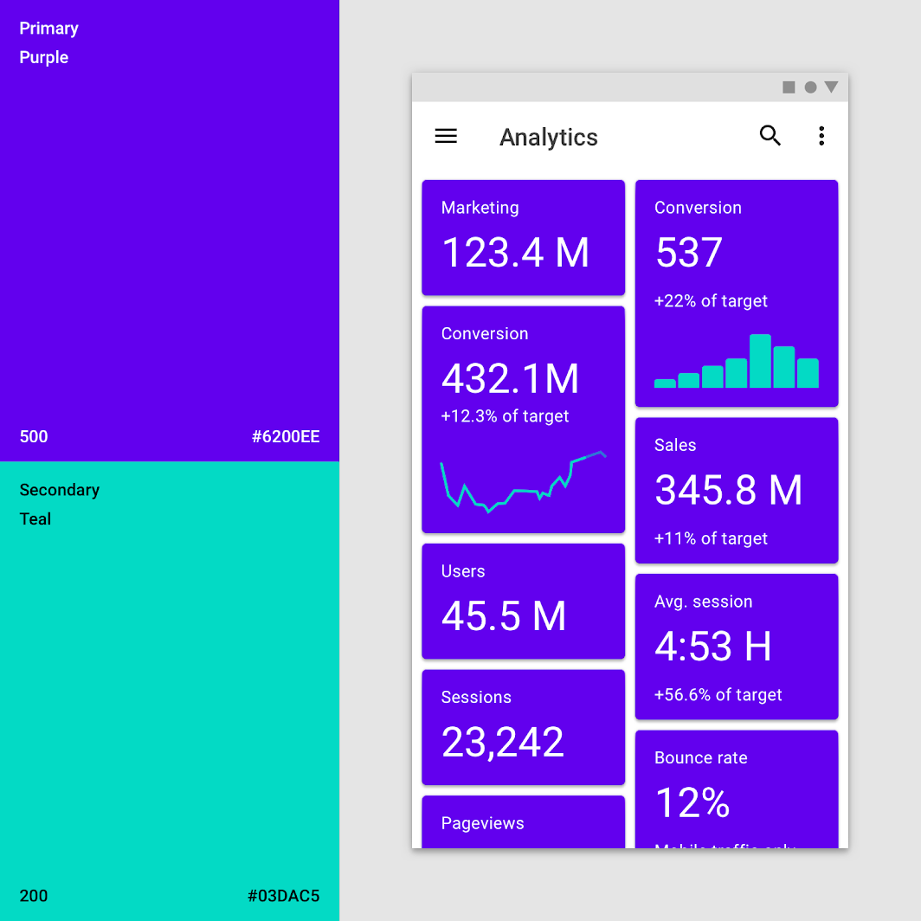

The surfaces of these cards use the primary color (purple 500). The app’s background color is white. The secondary color (teal 200) is used for data visualization.

volume\_off

Cards can inherit color to showcase selection or importance.

When a card’s text and icons appear in front of imagery, they can be difficult to read. To improve legibility, you can use color to create a surface for text and icons.

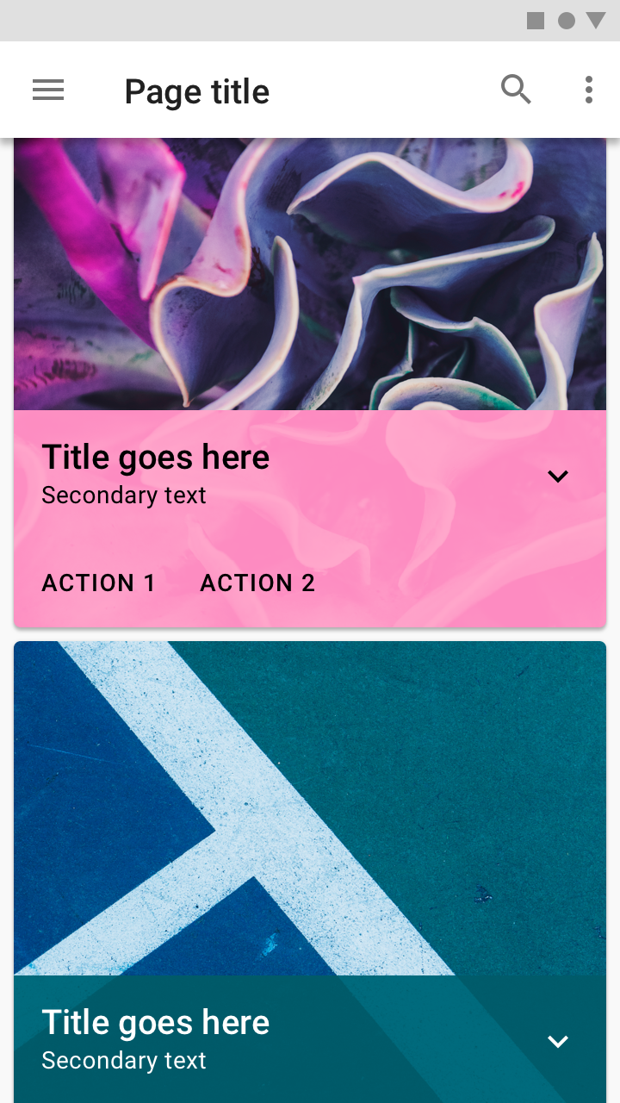

This card uses a colorful scrim to ensure text remains legible.

[Cards](https://m2.material.io/components/cards" \o "Cards" \t "_self)

[Containing content & links on a single subject](https://m2.material.io/components/cards" \o "Cards" \t "_self)

[Related articlearrow\_downward](https://m2.material.io/components/cards" \o "Cards" \t "_self)

**Buttons, chips and selection controls**link

Buttons, chips and selection controls can be emphasized by applying your primary or secondary color to them.

**Color categories**

* The baseline color for contained, text and outlined buttons is your **primary color**.
* The baseline color for floating action buttons and extended floating action buttons is your **secondary color**.
* The baseline color for selection controls is your **secondary color**.

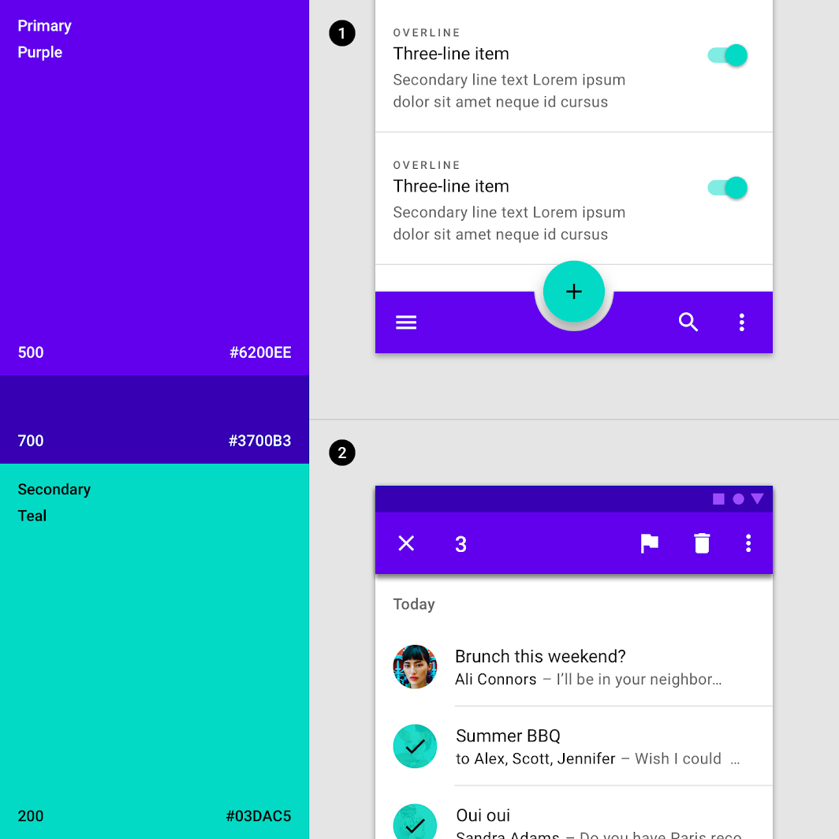

The color theme for this app consists of a primary color (purple 500) with a primary dark variant (purple 600) and a secondary color (teal 200).  
1. This product uses the primary color (purple 500) for the bottom app bar and the secondary color (teal 200) as an accent for the floating action button and selection controls.  
2. This product uses the secondary color (teal 200) as an accent for selected list items.

**Buttons, chips, and selection controls**

Buttons allow users to take actions with a single tap. Related Article arrow\_downward Chips are compact elements that represent an input, attribute, or action. Related...

Buttons, chips, and selection controls can be emphasized with your primary or secondary colors.

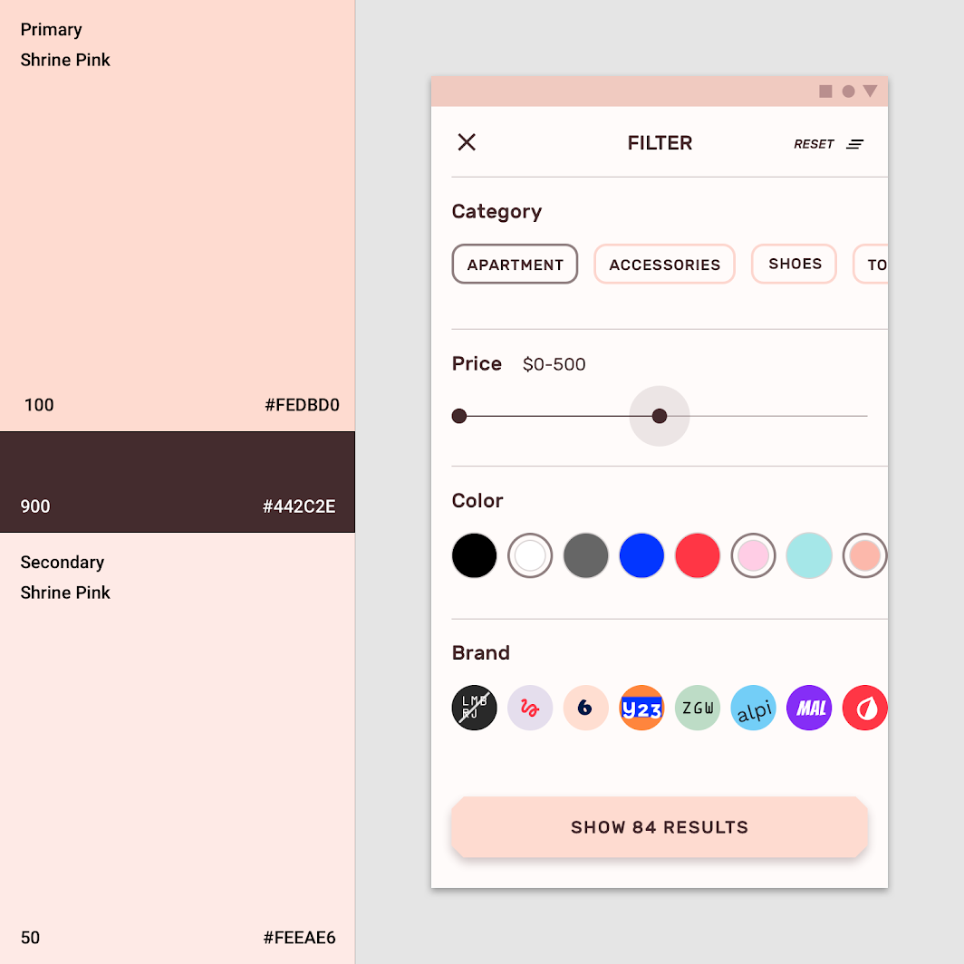

This app uses its primary color (pink 100) for its extended floating action button and chips. It uses its primary dark variant (pink 900) for the slider.

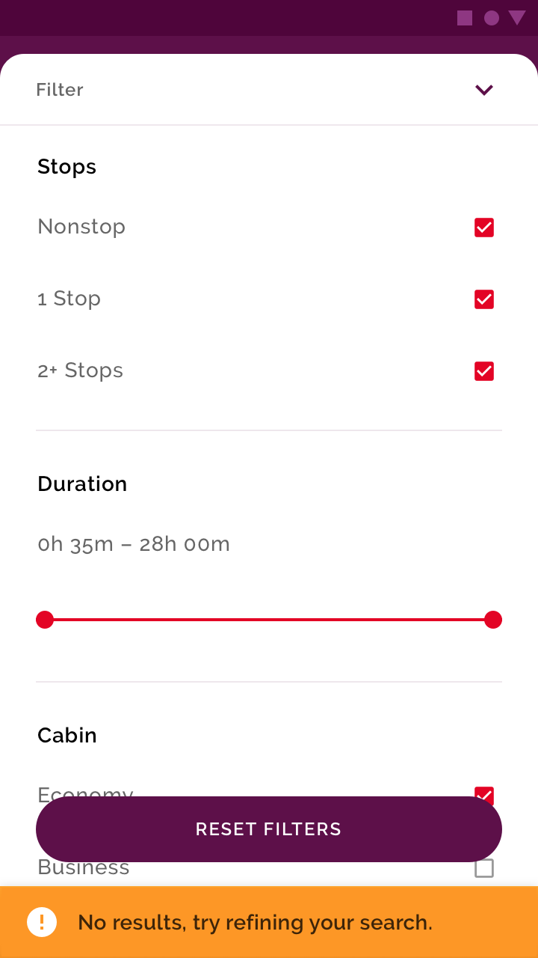

DoSelection controls can inherit your app’s secondary color.

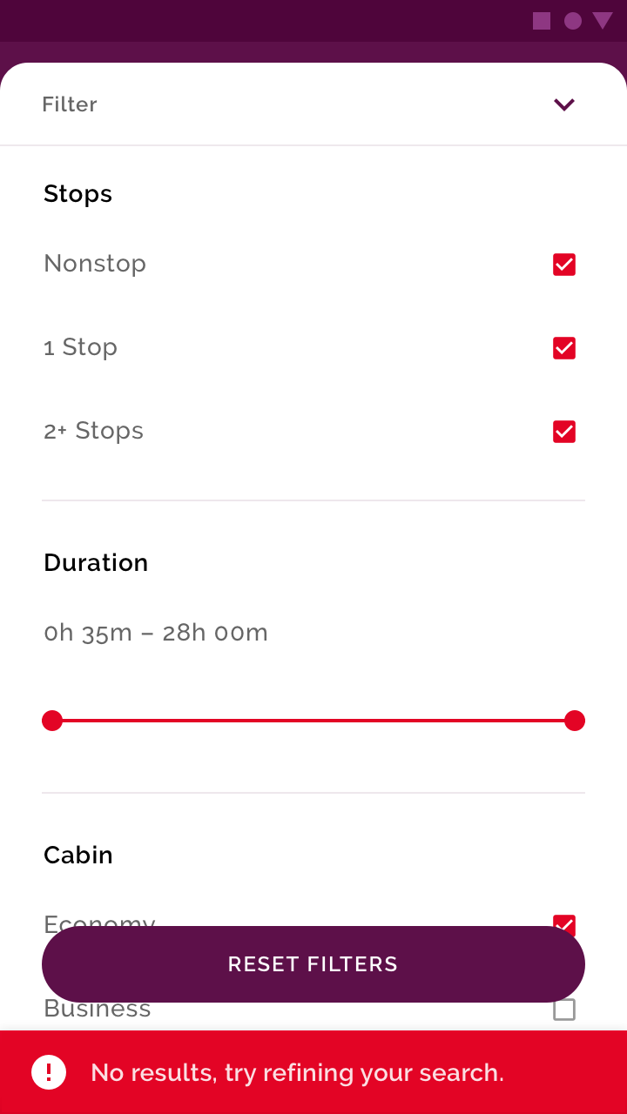

Don'tDon’t use one of your brand colors for coloring alerts. This will help it stand out.

[Buttons](https://m2.material.io/components/buttons" \o "Buttons" \t "_self)

[Buttons allow users to take actions with a single tap.](https://m2.material.io/components/buttons" \o "Buttons" \t "_self)

[Related articlearrow\_downward](https://m2.material.io/components/buttons" \o "Buttons" \t "_self)

[Chips](https://m2.material.io/components/chips" \o "Chips" \t "_self)

[Chips are compact elements that represent an input, attribute, or action.](https://m2.material.io/components/chips" \o "Chips" \t "_self)

[Related articlearrow\_downward](https://m2.material.io/components/chips" \o "Chips" \t "_self)

[Selection controls](https://m2.material.io/components/chips" \o "Selection controls" \t "_self)

[Selection controls allow the user to select options.](https://m2.material.io/components/chips" \o "Selection controls" \t "_self)

[Related articlearrow\_downward](https://m2.material.io/components/chips" \o "Selection controls" \t "_self)

[Owl](https://m2.material.io/design/material-studies/owl.html" \o "Owl" \t "_self)

[Owl is an educational app that provides courses for people who want to explore and learn new skills.](https://m2.material.io/design/material-studies/owl.html" \o "Owl" \t "_self)

[Related articlearrow\_downward](https://m2.material.io/design/material-studies/owl.html" \o "Owl" \t "_self)

[Crane](https://m2.material.io/design/material-studies/crane.html" \o "Crane" \t "_self)

[A travel app that uses Material Design components and Material Theming to create a personalized on-brand experience.](https://m2.material.io/design/material-studies/crane.html" \o "Crane" \t "_self)

[Related linkarrow\_downward](https://m2.material.io/design/material-studies/crane.html" \o "Crane" \t "_self)

[Shrine](https://m2.material.io/design/material-studies/shrine.html" \o "Shrine" \t "_self)

[Shrine is a lifestyle and fashion brand that demonstrates how Material Design can be used in e-commerce.](https://m2.material.io/design/material-studies/shrine.html" \o "Shrine" \t "_self)

[Related articlearrow\_downward](https://m2.material.io/design/material-studies/shrine.html" \o "Shrine" \t "_self)

**Floating action button (FAB)**

The floating action button (FAB) should be one of the most recognizable items on your screen. Use color to create contrast between the FAB and...

The floating action button (FAB) should be one of the most recognizable items on your screen.

Use color to create contrast between the FAB and surrounding elements, such as the app bar. Your secondary color is the baseline color for use on the FAB. If your canvas uses many colors, your FAB can use monochromatic coloring instead, to stand out from the content.

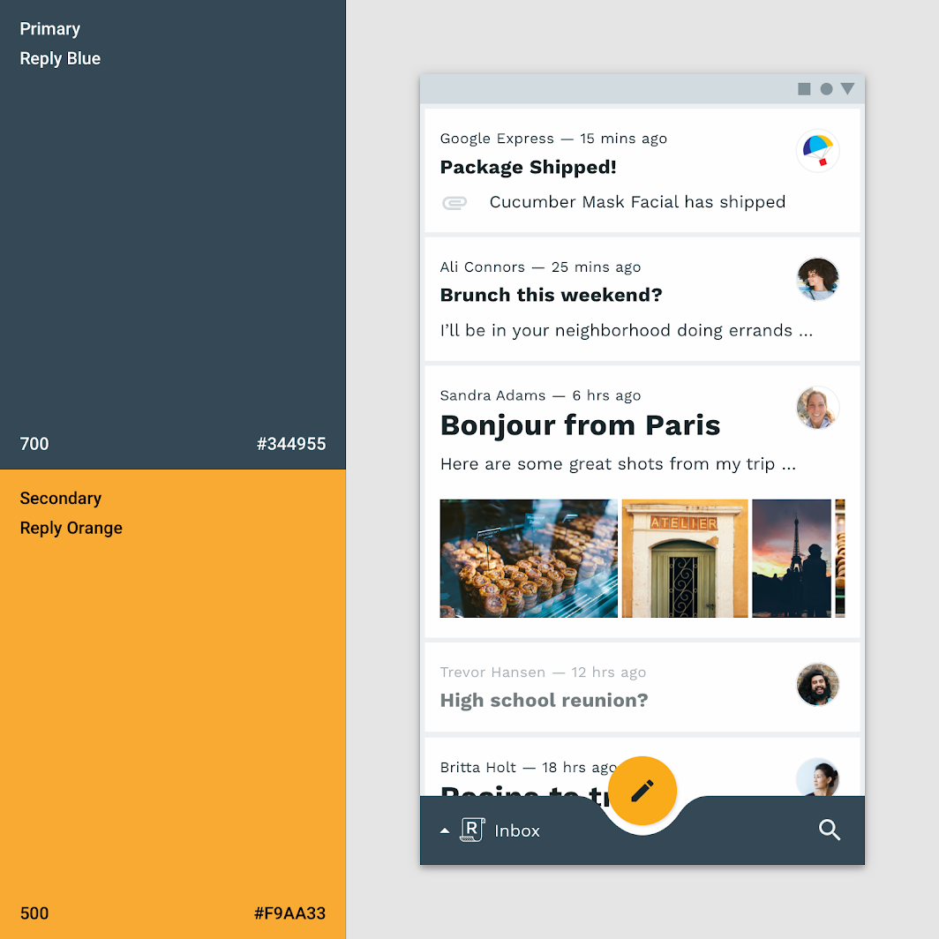

This app’s secondary color (orange 500) is applied to the FAB, contrasting it from the surrounding UI.

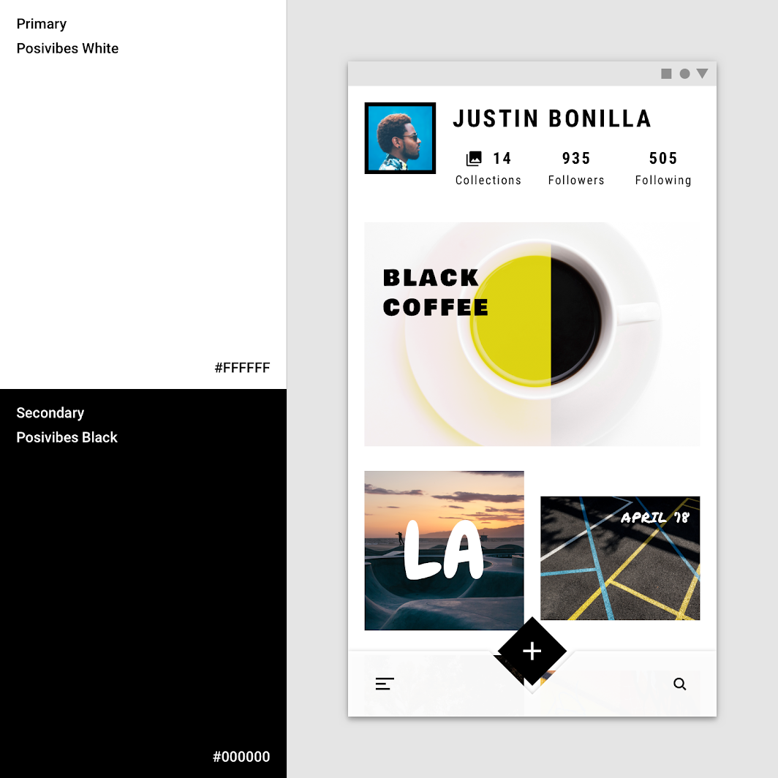

This app’s color theme uses a primary white and a secondary black for all buttons, selection controls, and iconography. These components stand out because they contrast with the vivid, multicolor content.

[Floating Action Button](https://m2.material.io/components/buttons-floating-action-button" \o "Floating Action Button" \t "_self)

[A floating action button (FAB) represents the primary action for a screen.](https://m2.material.io/components/buttons-floating-action-button" \o "Floating Action Button" \t "_self)

[Related articlearrow\_downward](https://m2.material.io/components/buttons-floating-action-button" \o "Floating Action Button" \t "_self)

[Reply](https://m2.material.io/design/material-studies/reply.html" \o "Reply" \t "_self)

[Reply is an email app that uses Material Design components and Material Theming to create an on-brand communication experience.](https://m2.material.io/design/material-studies/reply.html" \o "Reply" \t "_self)

[Related articlearrow\_downward](https://m2.material.io/design/material-studies/reply.html" \o "Reply" \t "_self)

**Typography and iconography**link

Color can express whether text has greater, or lesser, importance relative to other text. Color also ensures text remains legible when placed above imagery or backgrounds, which can make it difficult to read the text in front of them.

**Typographic hierarchy**

Color can increase both text’s visibility and its level of importance.

Color can increase both text’s visibility and its level of importance.

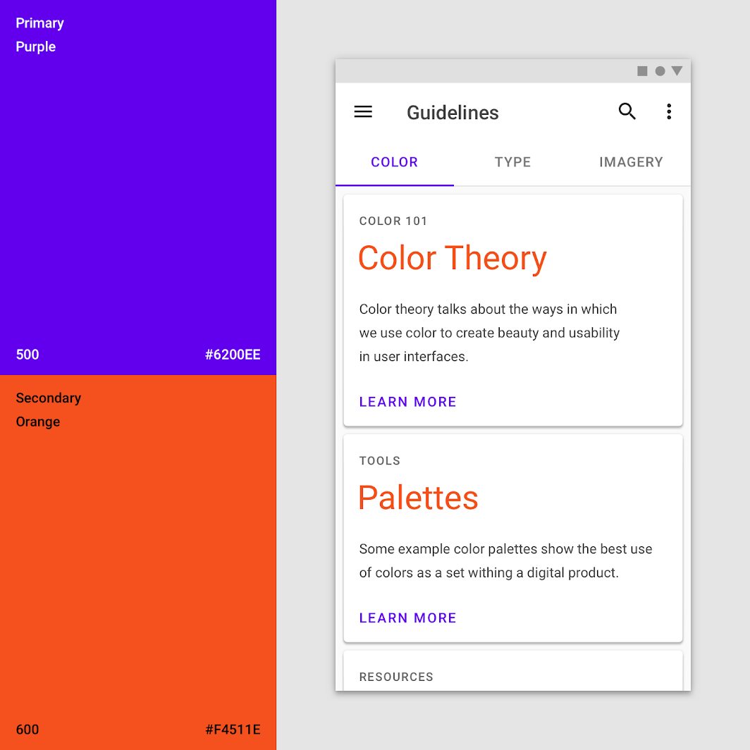

The color theme for this app consists of a primary color (purple 500) and a secondary color (orange 600). Orange accents the card’s headlines, and purple appears on tabs and buttons.

**Headlines and tabs**

Important text, like tabs and headlines, can use your primary or secondary color. Tabs organize high level content in an app content, such as switching...

Important text, like tabs and headlines, can use your primary or secondary color.

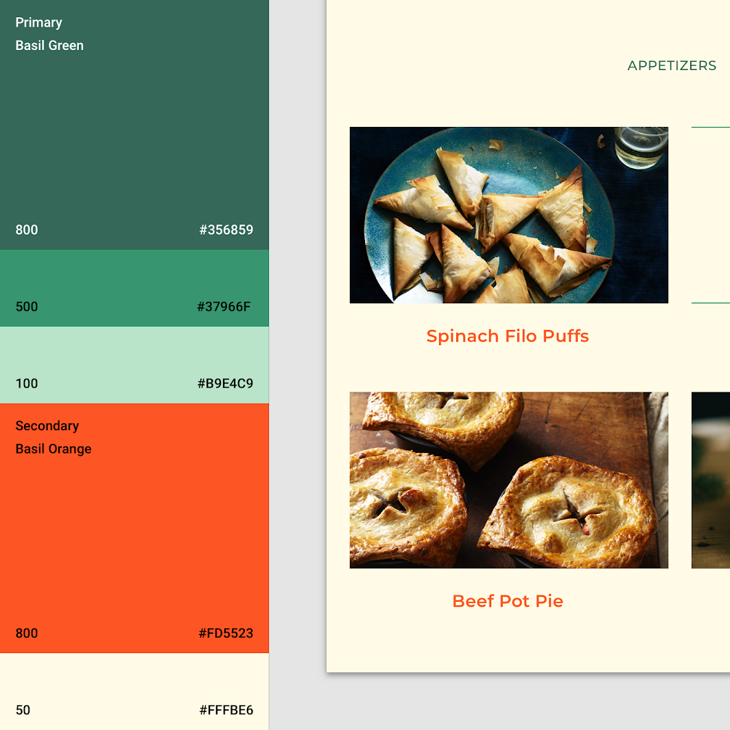

This app uses its secondary color (orange 800) to accent and call attention to the headlines.

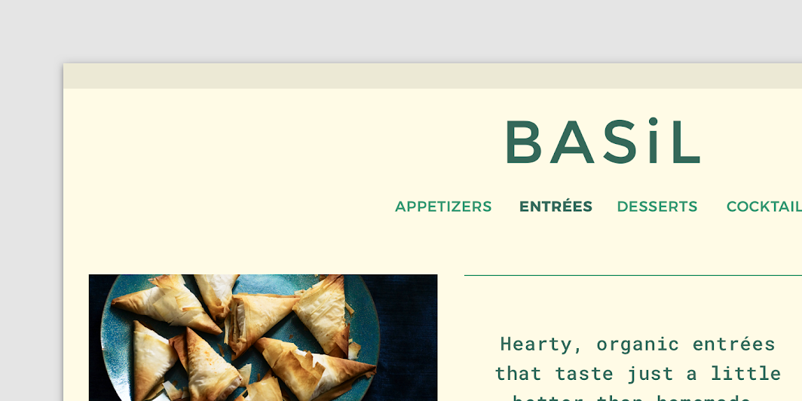

This app uses its primary color (green 800) for tabs, with weight changes indicating selected and unselected states.

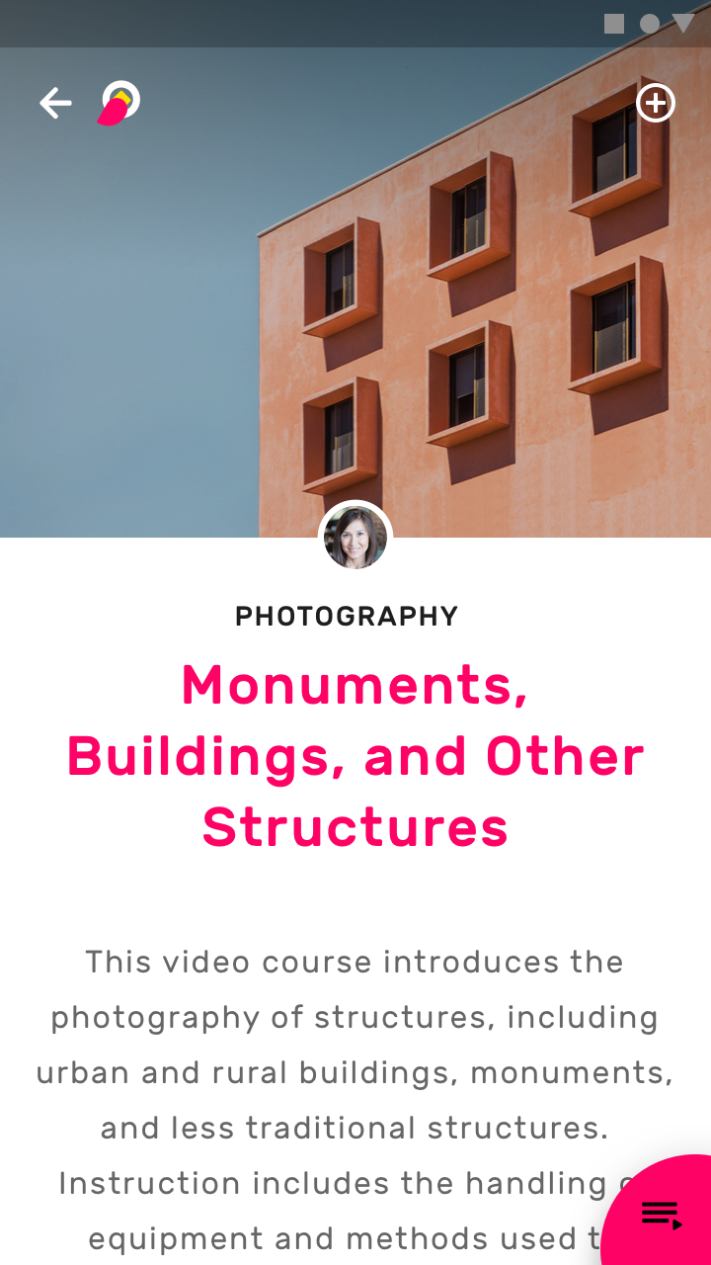

DoUse your primary or secondary color to emphasize shorter text, such as headlines.

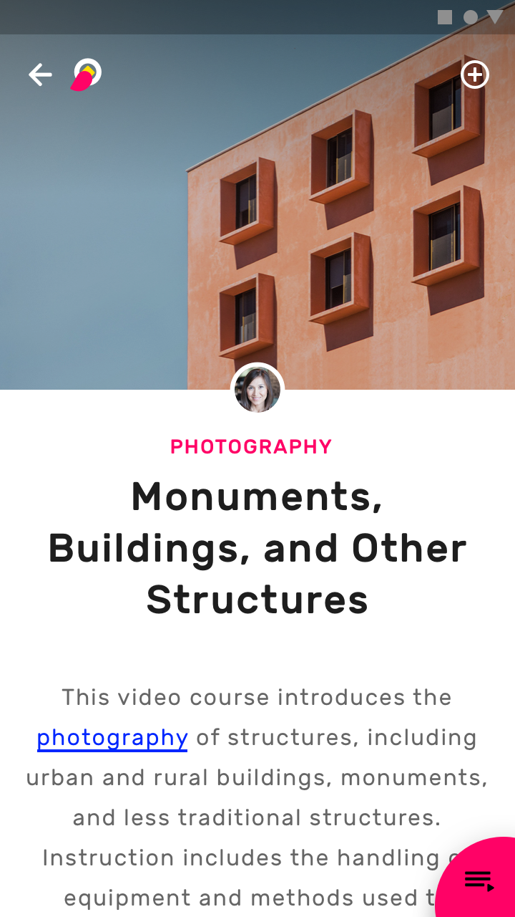

DoYou can use your primary or secondary color to accent links.

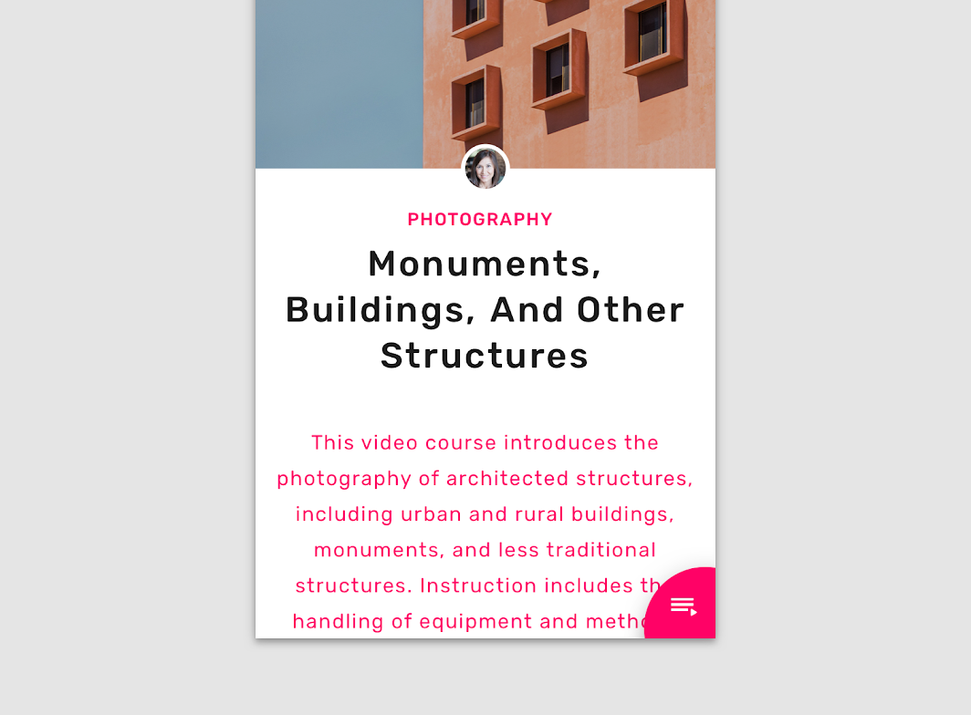

CautionAvoid using bright primary or secondary colors for body text.

[Tabs](https://m2.material.io/components/tabs" \o "Tabs" \t "_self)

[Tabs organize high level content in an app content, such as switching between views, data sets, or functional aspects of an app.](https://m2.material.io/components/tabs" \o "Tabs" \t "_self)

[Related articlearrow\_downward](https://m2.material.io/components/tabs" \o "Tabs" \t "_self)

[Basil](https://m2.material.io/design/material-studies/basil.html" \o "Basil" \t "_self)

[Basil is a recipe app that uses Material Design components and Material Theming to create an on-brand experience that is exciting and easy to explore.](https://m2.material.io/design/material-studies/basil.html" \o "Basil" \t "_self)

[Related linkarrow\_downward](https://m2.material.io/design/material-studies/basil.html" \o "Basil" \t "_self)

[Owl](https://m2.material.io/design/material-studies/owl.html" \o "Owl" \t "_self)

[Owl is an educational app that provides courses for people who want to explore and learn new skills.](https://m2.material.io/design/material-studies/owl.html" \o "Owl" \t "_self)

[Related articlearrow\_downward](https://m2.material.io/design/material-studies/owl.html" \o "Owl" \t "_self)

**Text legibility**

When text is placed above imagery, it often leads to legibility issues. Creating a colored layer between text and image can ensure text remains legible....

When text is placed above imagery, it often leads to legibility issues. Creating a colored layer between text and image can ensure text remains legible.



This app applies a yellow scrim above imagery to ensure text above it is legible.

[Tools for picking colors](https://m2.material.io/design/color/the-color-system.html" \l "tools-for-picking-colors" \o "Tools for picking colors" \t "_self)

[The Material Design color system helps you choose colors for your user interface.](https://m2.material.io/design/color/the-color-system.html" \l "tools-for-picking-colors" \o "Tools for picking colors" \t "_self)

[Related articlearrow\_downward](https://m2.material.io/design/color/the-color-system.html" \l "tools-for-picking-colors" \o "Tools for picking colors" \t "_self)

**Icons**

Icons help identify actions and provide information. Their color should contrast against the background to ensure that they are legible and identifiable. Basil is a...

Icons help identify actions and provide information. Their color should contrast against the background to ensure that they are legible and identifiable.

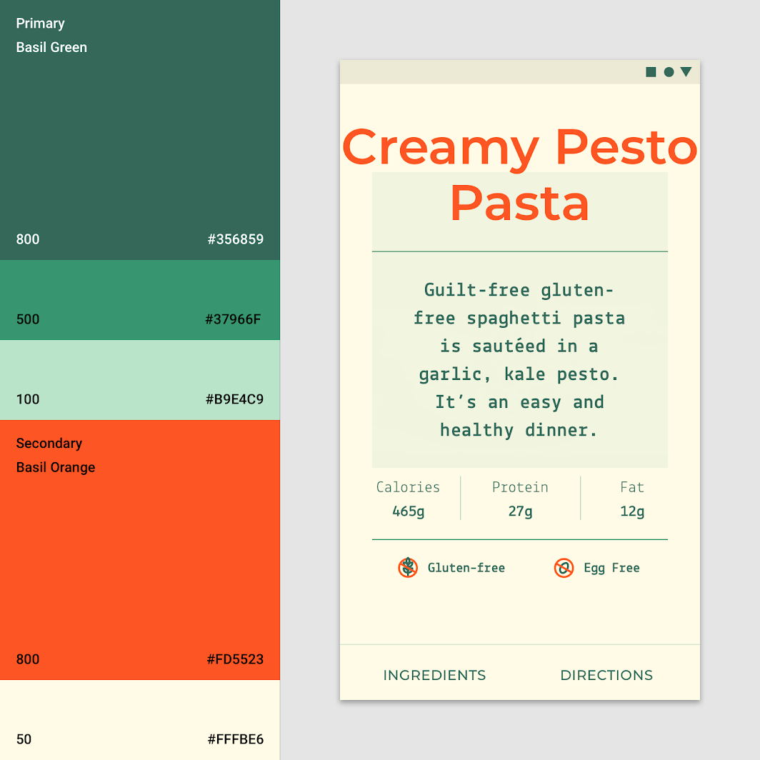

This app uses both its primary color (green 800) and secondary color (orange 800) for its icons.

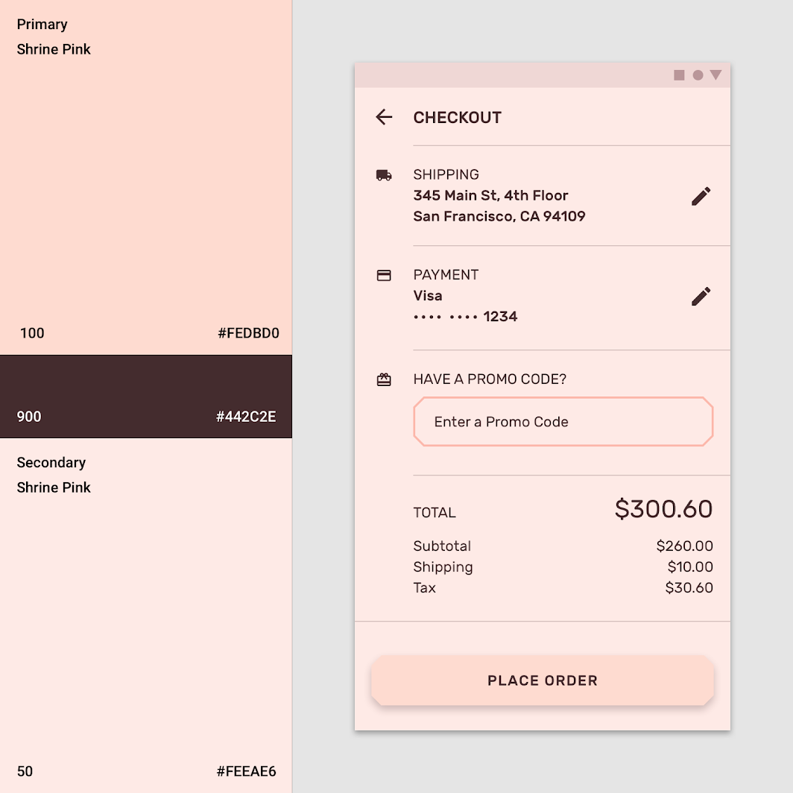

Shrine uses its primary dark variant (pink 900) for icons.